SPEECH EMOTION RECOGNITION

Bachelor of Technology
In

Computer Science and Engineering (Internet of Things)
By

L.MURARI 2211CS050058

Under the esteemed guidance of

Mrs. K. Rashmi



Department of Computer Science & Engineering (Internet of Things)

School of Engineering

MALLA REDDY UNIVERSITY
Maisammaguda, Dulapally, Hyderabad, Telangana 500100

2024



Department of Computer Science & Engineering (Internet of Things)

CERTIFICATE

This is to certify that the project report entitled “SPEECH EMOTION RECOGNITION”, submitted by L.Murari (2211CS050058), of 3-year IoT – ALPHA Department of Computer Science and Engineering, Malla Reddy University, Hyderabad, is a record of bonafide work done by him/ her. The results embodied in the work are not submitted to any other University or Institute for the award of any degree or diploma.

Internal Guide Head of the Department

Mrs. K. Rashmi Dr. G. Anand Kumar

HOD CSE(Cyber Security & IoT)

External Examiner

DECLARATION

We hereby declare that the project report entitled “SPEECH EMOTION RECOGNITION ”, has been carried out by us. This work has been submitted to the Department of Computer Science and Engineering (Internet of Things), Malla Reddy University, Hyderabad for the award of the degree of Bachelor of Technology. We further declare that this project work has not been submitted in full or in part for the award of any other degree in any other educational institutions.

Place:
Date:

L.Murari 2211CS050058

ACKNOWLEDGEMENT

We extend our sincere gratitude to all those who have contributed to the completion of this project report. Firstly, we would like to extend our gratitude to Dr. V. S. K Reddy, Vice-Chancellor, for his visionary leadership and unwavering commitment to academic excellence.

We would also like to express our deepest appreciation to our project guide Mrs. K. Rashmi Assistant Professor, Dept. of Cyber Security & IoT, whose invaluable guidance, insightful feedback, and unwavering support have been instrumental throughout this project for successful outcomes.

We are also grateful to Dr. G. Anand Kumar, Head of the Department of Cyber Security & IoT, for providing us with the necessary resources and facilities to carry out this project.

We extend our gratitude to our PRC-convenor, Dr. G. Latha, for giving valuable inputs and timely guidelines to improve the quality of our project through a critical review process. We thank our project coordinator, Dr. G. Latha, for his timely support.

We would like to thank Dr. Kasa Ravindra, Dean, School of Engineering, for his encouragement and support throughout my academic pursuit.

My heartfelt thanks also go to Dr. Harikrishna Kamatham, Associate Dean School of Engineering for his guidance and encouragement.

We are deeply indebted to all of them for their support, encouragement, and guidance, without which this project would not have been possible.

L.Murari 2211CS050058

ABSTRACT

This research explores the development of a machine learning-based Speech Emotion Recognition (SER) system designed to accurately detect and categorize human emotions from vocal inputs. The system employs advanced acoustic analysis, focusing on features like pitch, intensity, and speech rate, to capture emotional subtleties in speech. Leveraging algorithms such as Support Vector Machines (SVM), Random Forest, and Naive Bayes, the model is trained on a wide array of emotional datasets, enabling effective performance across diverse languages and accents. To improve the accuracy of emotion detection, feature selection methods and ensemble learning are incorporated, enhancing the model’s precision. Beyond emotion classification, the system generates graphical representations of emotional patterns and provides text transcriptions of the audio input, adding depth to the analysis. Potential applications span multiple domains: from improving human-computer interaction in virtual assistants and customer service systems by recognizing emotional cues to assisting mental health professionals with tools for emotional assessment. The long-term objective envisions real-time emotion recognition, fostering more adaptive and intuitive user experiences across various interactive platforms. Integrating speech-to-text capabilities further enriches the system, transforming vocal expressions into textual and emotional insights.

List of Diagram
Figure 3.3.1 Architectural Diagram 11
Figure 3.3.2 Data Flow Diagram 13
Figure 3.3.3 Class Diagram 14
Figure 3.3.4 Use case Diagram 16
Figure 3.3.5 Sequence Diagram 17
Figure 3.3.6 Activity Diagram 19

List of Screenshots
Screenshot 4.3.1 User Interface 42
Screenshot 4.3.2 Uploading audio files 43
Screenshot 4.3.3 Spectrogram for audio files 43
Screenshot 4.3.3 Live voice input and result 44
Screenshot 5.1 Live voice input and result 45

Table of Contents

Contents Page No.

Chapter 1 Introduction 01-02

  - Problem Definition & Description 01

  - Objectives of the Project 01

  - Scope of the Project 01-02

Chapter 2 System Analysis 03-07

  - Existing System 03-05

    - Background & Literature Survey 03-04

    - Limitations of Existing System 04-05

  - Proposed System 05-06

    - Advantages of Proposed System 06

  - Software & Hardware Requirements 06-07

    - Software Requirements 06

    - Hardware Requirements 07

  - Feasibility Study 07

    - Technical Feasibility 07

    - Robustness & Reliability 07

    - Economic Feasibility 07

Chapter 3 Architecture Design 08-20

  - Modules Design 08-09

    - Data Collection and Preprocessing Module 08

    - Feature Extraction Module 08

    - Model Training Module 08

    - Emotion Classification Module 08
    - Speech-to-Text (STT) Module 09
    - GUI Module 09
  - Method & Algorithm Design 09-10
    - Data Preprocessing Methods 09
    - Machine Learning Models for Emotion Classificatio 10
    - Speech-to-Text Algorithms 10
    - Real-time Processing Techniques 10
  - Project Architecture 11-20
    - Architectural Diagram 11-12
    - Data Flow Diagram 13-14
    - Class Diagram 14-15
    - Use case Diagram 16-17
    - Sequence Diagram 17-18
    - Activity Diagram 19-20
Chapter 4 Implementation & Testing 21-28
  - Coding Blocks 21-27
    - Import necessary libraries 21
    - Feature Extraction 21
    - Generate and plot spectrogram 21-22
    - Speech-to-text conversion 22
    - Load dataset and extract features 23
    - Load and preprocess data 23
    - Train models 24
    - Evalution 24
    - Predict emotion 25
    - Live voice input 25
    - Predict live emotion 25-26
    - Tkinter GUI with speech-to-text 26
    - Tkinter GUI 27
  - Execution Flow 27-28
    - Initialization 27
    - Model Training 27

4.2.3 | GUI Interaction File Upload or Live Voice | 28
4.2.4 | Results Display and GUI Main Loop | 28

Chapter 5 Results 29-30
5.1 Resulting Screen 29-30

Chapter 6 Conclusions & Future Scope 31-32
  - Conclusions 31
  - Future Scope 31-32

Bibliography 32

Paper Publication 33-38

Poster 39




CHAPTER-1 INTRODUCTION

Problem Definition & Description

Previous attempts at developing a Speech Emotion Recognition (SER) system with speech-to-text capabilities faced challenges impacting both model accuracy and usability. A key issue was the inconsistency in feature extraction from audio files, as features like MFCCs, chroma, and mel- spectrograms didn’t consistently capture emotion across different speakers, languages, and recording conditions. This variation led to poor model performance, especially with diverse accents and emotional expressions. Additionally, integrating the models into a Tkinter-based GUI presented issues, with instances of lag or failure in displaying results, affecting the overall responsiveness. These challenges emphasize the need for enhanced noise reduction, more robust features, and improved model generalization for future iterations.

Objectives of the Project

The project involves building a comprehensive machine-learning system for Speech Emotion Recognition (SER) combined with speech-to-text functionality. This dual-purpose application is designed to analyze audio inputs in real-time, identifying emotions while transcribing spoken content into text. Through a Tkinter-based graphical interface, users can upload audio files, view spectrograms, get predictions on emotional tone, and receive transcriptions of the spoken content. The system’s design prioritizes versatility, targeting applications in human-computer interaction, emotion analysis, and assistive technologies. Key objectives include achieving high accuracy in emotion recognition across various speech patterns, improving the robustness of feature extraction techniques like MFCCs and chroma, and ensuring the application performs consistently with diverse languages and accents.

Scope of the Project
The scope of this Speech Emotion Recognition (SER) and speech-to-text project is broad, encompassing the development of a reliable, interactive application that leverages advanced machine learning techniques to analyze vocal inputs and transcribe speech. The system aims to support nuanced emotion detection across a wide range of voices, accents, and languages, making it adaptable to diverse user needs and environments. With potential applications in fields like human-computer interaction, virtual assistants, mental health assessment, and customer service, this project addresses the growing demand for technology that can interpret and respond to human emotions. By combining SER with speech-to-

1

text conversion in a user-friendly Tkinter interface, the project also aims to enhance accessibility and user engagement, providing a tool that can integrate into assistive technologies and interactive systems. The key components and features to be included in the system are:

    - Enhanced Emotion Recognition: Uses machine learning models to detect emotions from audio, enhancing interactions with computers and virtual assistants.
    - Speech-to-Text Functionality: Converts audio input to text, making the tool versatile for transcription and analysis.
    - User-Friendly GUI: A Tkinter interface enables easy interaction, allowing users to upload audio, view spectrograms, and access predictions and transcripts.
    - Application in Multiple Fields: Relevant to sectors like human-computer interaction, emotion analysis, assistive technology, mental health, and customer service.

CHAPTER-2 SYSTEM ANALYSIS

Existing System

Background & Literature Survey

The literature on Speech Emotion Recognition (SER) encompasses a variety of approaches, techniques, and applications aimed at enhancing the accuracy and reliability of emotion detection from vocal inputs. Many studies highlight the importance of feature extraction methods, with research by S. K. Saha et al. (2020) focusing on acoustic features such as pitch, energy, and speech rate, which are pivotal in distinguishing between different emotional states. The use of machine learning algorithms, particularly Support Vector Machines (SVM) and Random Forests, has been prevalent in recent works due to their effectiveness in classifying emotions based on extracted features.

“Speech Emotion Recognition Using Machine Learning Techniques” was proposed by Saha, Ghosh, and Mandal provide a comparative analysis of machine learning techniques used in SER, specifically focusing on algorithms like Support Vector Machines (SVM), Random Forest, Decision Trees, and K- Nearest Neighbors (KNN). Through experiments conducted on diverse audio datasets, the authors evaluate each algorithm’s effectiveness in emotion classification. The study emphasizes the importance of factors such as computational efficiency, accuracy, and scalability, particularly in real-world applications where resource limitations may be a concern. Their analysis provides insights into the trade- offs associated with different algorithms, helping to guide the selection of suitable techniques for robust SER systems that can operate effectively in practical scenarios.

A paper named “Speech Emotion Recognition Using Deep Neural Network and Extreme Learning Machine” was put forward by “K. Han & I. Tashev”. Their study demonstrates the effectiveness of DNNs in automatically learning hierarchical features from raw audio data, resulting in improved emotion recognition performance compared to traditional feature extraction methods. While DNNs offer high accuracy, they also present challenges in terms of computational efficiency. The authors note that DNNs are resource-intensive, making them less suitable for real-time or resource-constrained environments. As a potential solution, Han and Tashev propose hybrid approaches that combine the strengths of deep learning with traditional algorithms to strike a balance between performance and efficiency. Their work highlights both the promise and limitations of deep learning in SER, advocating for innovative approaches to address computational demands.

“IEMOCAP: Interactive Emotional Dyadic Motion Capture Database” which was proposed by “C. Busso, M. Bulut, C. Lee, A. Kazemzadeh, E. Mower, S. Kim, J. Chang, & S. Narayanan”. The IEMOCAP dataset, introduced by Busso et al., is a cornerstone in SER research, offering a multimodal collection of emotional data that includes audio, video, and motion-capture information. This dataset contains recordings of actors engaged in scripted and spontaneous dialogues, enabling a wide range of emotional expressions to be captured and studied. Its multimodal nature allows researchers to analyze emotions through audio cues, such as pitch and tone, alongside visual gestures and facial expressions.

“Speech Emotion Recognition: Features, Classification Schemes, and Databases” was proposed by El Ayadi, M., Kamel, M. S., & Karray, F. (2011). In this comprehensive survey, El Ayadi et al. explore various techniques and models used in Speech Emotion Recognition (SER). They discuss both classical and advanced classification models, such as Gaussian Mixture Models (GMM), Support Vector Machines (SVM), and Neural Networks. The paper underscores the importance of selecting appropriate features, as this can significantly improve model accuracy. El Ayadi et al. also examine a range of emotional datasets, emphasizing the need for multilingual and diverse datasets to enhance the generalizability of SER systems. Their findings provide valuable insights for researchers aiming to create systems capable of managing a variety of linguistic and acoustic inputs.

Limitations of Existing System

The existing Speech Emotion Recognition (SER) system, while functional in certain controlled applications, faces notable limitations that impact its effectiveness, adaptability, and user accessibility. These limitations stem from the system’s design, which focuses on traditional feature extraction and statistical modeling approaches. This focus constrains the system’s performance in dynamic, real-time scenarios and hinders its ability to handle diverse and complex emotional cues. Additionally, the system’s user interaction capabilities are minimal, limiting its usability for broader, more interactive applications. Addressing these limitations is essential to enhance the system's scalability, accuracy, and ease of use in practical, real-world environments. The existing system has several limitations that restrict its effectiveness and applicability in modern use cases.

Lack of Real-Time Processing: One major limitation is its inability to process audio data in real time, as it is designed to analyze only pre-recorded speech samples. This restricts its application in scenarios where immediate emotion recognition is essential, such as in live customer service interactions, virtual assistants, or assistive technology tools where instantaneous feedback is needed.

Traditional Feature Extraction Methods: The system relies on fundamental temporal and spectral features, which may not capture the more intricate emotional nuances present in audio signals. This

approach misses out on more sophisticated insights that advanced techniques, such as detailed spectrogram analysis, could reveal, potentially limiting the system’s ability to accurately recognize subtle emotions.

Dependence on Statistical Models: By relying on models such as Gaussian Mixture Models (GMM), the system may struggle to capture the full complexity of emotional expressions, which are often highly variable. Statistical models like GMM may be too rigid to account for these variations, resulting in limited accuracy when dealing with more dynamic emotional cues.

Limited Scalability: The system’s use of traditional feature sets can pose challenges when attempting to scale to larger or more diverse datasets. Advanced datasets often require deeper analysis and sophisticated feature extraction techniques, and without these capabilities, the system may not perform well on more complex or varied data, reducing its adaptability.

User Interaction Constraints: The absence of a graphical user interface (GUI) makes the system less user-friendly. Users have no visual support to help guide them through the process of inputting audio data or interpreting the system's outputs. This lack of interactive elements may make the system challenging to use, particularly for users unfamiliar with technical audio processing or those who rely on visual aids for better usability.

Proposed System
The proposed Speech Emotion Recognition (SER) system is designed to build an advanced machine- learning framework capable of accurately detecting and categorizing human emotions from vocal cues. By employing a combination of refined feature extraction methods and diverse machine learning algorithms, the system analyzes audio samples to interpret emotional content with precision. Acoustic features such as Mel-frequency cepstral coefficients (MFCCs), chroma, and mel spectrograms are extracted from the audio, offering a rich foundation for understanding the underlying emotional state. The system utilizes a set of classifiers, including Random Forest, Support Vector Machines (SVM), and Naive Bayes, to improve the consistency and reliability of emotion recognition. To enable real-time emotion analysis, the system is equipped with a Tkinter-based graphical user interface (GUI), making it easy for users to upload and analyze audio files. It also includes a speech-to-text feature, converting spoken language into written text alongside emotion detection results, thus providing users with both a transcription and an emotional profile of the speech. The system’s comprehensive design aims to improve human-computer interaction in fields like virtual assistance and customer support, as well as provide mental health professionals with insights into emotional expressions. This real-time emotional feedback system can adapt and respond empathetically, enhancing user experience in a wide range of scenarios. In

summary, the proposed SER system represents a step forward in emotion recognition, using sophisticated machine learning and feature extraction to analyze vocal inputs effectively. The intuitive interface and transcription capabilities make it highly applicable for virtual assistants, customer service, and mental health support, promoting a more responsive and empathetic user interaction.

Advantages of Proposed System

      - The proposed system’s ability to process live voice input enables it to identify emotional states as they occur, offering immediate feedback during interactions. This real-time capability is particularly valuable in scenarios such as virtual assistants, customer support, and therapeutic settings, where timely emotional awareness can enhance the quality of the interaction and improve user satisfaction.
      - By leveraging ensemble learning techniques, the system combines the strengths of multiple models, which enhances its overall accuracy and robustness. This approach minimizes the risk of overfitting, allowing the model to generalize effectively on new, unseen data. As a result, the system becomes more reliable at recognizing emotions across a variety of vocal patterns and conditions, leading to improved predictive performance.
      - The system is designed with a scalable architecture that can support future improvements and accommodate emerging technologies. This scalability makes it easy to integrate deep learning methods or expand the system to classify additional emotional categories, ensuring its adaptability and relevance as new research and technologies emerge in the field of emotion recognition.
      - The dual-output functionality offers a more comprehensive understanding of both the emotional tone and the content of the speech, which is particularly useful in applications such as mental health care and customer feedback analysis, where both emotional insights and textual content are critical.
      - The system is designed with a user-friendly interface that caters to individuals with varying technical skill levels. This intuitive design encourages easy adoption across different sectors, including customer support and mental health care, by making complex emotion recognition technology accessible and straightforward to use for all users, regardless of their technical background.

Software & Hardware Requirements

Software Requirements

      - Libraries and Frameworks
      - Operating System
      - IDE/Development Tools
      - Programming Languages

Hardware Requirements

      - Laptop with 8 GB RAM
      - Processor (CPU)
      - Memory (RAM)
      - Storage
      - Graphics

Feasibility Study

Technical Feasibility

The technical feasibility of the proposed Speech Emotion Recognition (SER) system is strong, as it can be effectively implemented using widely available technologies. Python, along with libraries like Scikit- learn, TensorFlow, and Librosa, provides robust support for machine learning and audio processing tasks. Tkinter allows for an intuitive GUI design, ensuring ease of use. The system can operate on standard hardware with at least 8 GB of RAM and a modern CPU. Additionally, integrating speech-to-text functionality using libraries like Speech Recognition is straightforward. Overall, the project is technically achievable with current software tools and hardware.

Robustness & Reliability

The robustness and reliability of the proposed Speech Emotion Recognition (SER) system are ensured by using a combination of ensemble models and advanced feature extraction techniques like MFCCs, chroma, and mel spectrograms, which enhance the system's ability to generalize across diverse emotional expressions and speech conditions. The integration of speech-to-text functionality further boosts reliability by providing accurate transcriptions. The system is designed to handle both pre-recorded and live voice inputs with an intuitive GUI, ensuring consistent performance. Its scalability allows for future improvements, maintaining reliability as new technologies and datasets evolve.

Economic Feasibility

The economic feasibility of the Speech Emotion Recognition (SER) system is high due to its use of cost- effective, open-source tools and libraries like Python and Scikit-learn. The system can run on standard hardware, minimizing infrastructure costs. Additionally, integrating existing speech-to-text and machine learning models reduces development expenses. With scalability for future upgrades, the system offers long-term value, making it an affordable and economically viable solution for industries such as customer service and mental health.

CHAPTER-3 ARCHITECTURAL DESIGN

Modules Design

Data Collection and Preprocessing Module

      - Collect diverse audio datasets representing various emotions, languages, and accents.

      - Clean the data by removing noise, normalizing volume levels, and fixing corrupted files.

      - Augment the dataset through techniques like pitch shifting or time stretching to increase variability.

      - Ensure consistency in the format of audio files (e.g., WAV or MP3) for uniformity during processing.

Feature Extraction Module

      - Extract MFCC (Mel-frequency cepstral coefficients) to capture speech timbre and rhythm.

      - Use Chroma features to analyze the harmonic content and tonality of speech.

      - Generate Mel-spectrograms to capture frequency content and time variation in speech.

      - Apply noise reduction methods to improve feature quality and robustness against environmental noise.

Model Training Module

      - Split the dataset into training, validation, and test sets to avoid overfitting.

      - Train models like SVM, Random Forest, and Naive Bayes on the extracted features.

      - Use cross-validation to fine-tune hyperparameters for optimal performance.

      - Evaluate models' performance on different datasets to ensure robustness across emotional variations and speech patterns.

Emotion Classification Module

      - Classify emotions such as happiness, sadness, and anger based on the extracted features.
      - Implement multi-class classification using Softmax for probability prediction.
      - Use ensemble learning techniques to combine multiple model predictions for better accuracy.
      - Optimize the system to perform well across various emotional expressions and diverse accents.

Speech-to-Text (STT) Module

      - Integrate an STT API (e.g., Google Speech-to-Text) to convert speech into written text.

      - Preprocess audio inputs to reduce noise and ensure clarity before passing them to the STT system.

      - Handle issues like background noise, accents, and speech clarity to improve transcription accuracy.

      - Display transcribed text on the GUI alongside emotion prediction.

GUI Module

      - Design a user-friendly interface that allows users to upload audio files.

      - Display emotion predictions and transcriptions clearly on the GUI.

      - Include audio visualizations (e.g., waveform or spectrogram) for a detailed view of speech data.

      - Provide real-time feedback on emotions and text when users speak into the microphone.

Model Evaluation and Improvement Module

      - Evaluate model performance using metrics like accuracy, precision, recall, and F1-score.
      - Perform error analysis to understand model weaknesses and areas for improvement.
      - Use transfer learning to fine-tune models with new datasets or pretrained models.

Model Evaluation and Improvement Module

      - Capture live audio input from a microphone for real-time processing.
      - Extract features from live audio and classify emotions as the speech occurs.
      - Ensure low-latency processing for fast, real-time predictions and feedback.
      - Integrate both emotion recognition and speech-to-text for live interaction.

Methods & Algorithm Design

Data Preprocessing Methods

In the data preprocessing step, the focus is on preparing the raw audio data for further analysis. First, noise reduction techniques like spectral subtraction are applied to eliminate unwanted background noise, ensuring that only the speech signal remains. Volume normalization is performed to ensure consistent audio levels across different files. Additionally, resampling is used to standardize the sample rate of all audio files, which is crucial for uniformity when extracting features. Augmentation techniques such as

pitch shifting or time-stretching may also be used to create variations in the dataset, improving the model’s ability to handle different accents, speaking speeds, and environmental conditions.

Machine Learning Models for Emotion Classification

In the emotion classification step, machine learning algorithms are trained to identify emotional states from the features extracted in the previous step. Support Vector Machines (SVM) are often used for this task due to their effectiveness in high-dimensional spaces, making them well-suited for handling the complexity of audio features. Random Forest classifiers, which build an ensemble of decision trees, are also employed to improve robustness and reduce overfitting. Naive Bayes, a probabilistic model, can be used to classify emotions by calculating the likelihood of features belonging to different emotion classes.

Speech-to-Text Algorithms

The Speech-to-Text (STT) module is responsible for transcribing spoken language into written text. This can be achieved through the integration of existing speech recognition systems like Google Speech- to-Text API, which uses deep learning models to convert speech into text with high accuracy. Another option is CMU Sphinx, an open-source system that works well in controlled environments but may require further optimization for diverse speech samples. DeepSpeech, an open-source deep learning model developed by Mozilla, can also be used for this task, providing a more flexible, end-to-end solution for converting speech to text in various conditions. Preprocessing the audio to remove noise and normalize volume is important to ensure high transcription accuracy, especially in noisy or challenging environments.

Real-time Processing Techniques

Real-time emotion recognition is a critical aspect of the project, where the system must process live audio inputs and classify emotions instantaneously. To achieve this, techniques like the sliding window are employed, where the audio stream is divided into short, overlapping segments. These segments are then processed for feature extraction and emotion classification, providing real-time feedback. To further optimize real-time processing, online learning techniques are used, enabling the model to update and adapt based on new incoming data, such as changes in a speaker’s emotional state. Low-latency processing is key here, ensuring that feature extraction, classification, and feedback happen quickly enough for seamless interaction, especially for use cases such as virtual assistants or live customer service applications.

Project Architecture

Architectural Diagram

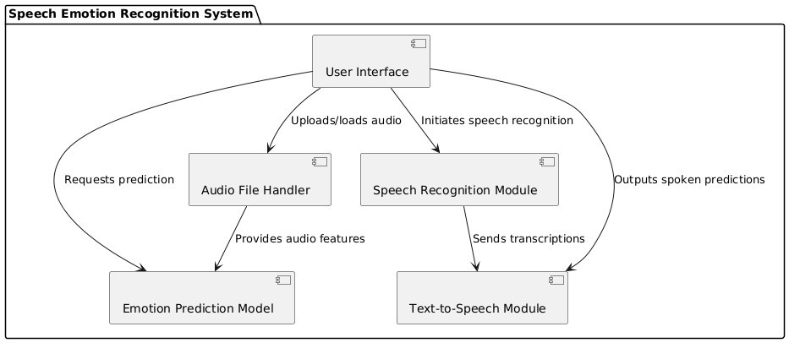
Figure 3.3.1 Architectural Diagram

      - User Interface (UI) Module: The User Interface (UI) Module serves as the primary point of interaction between the user and the system. Its main function is to capture the user's input, whether it’s through an audio file upload or live voice input via a microphone. The user can upload audio files (e.g., .wav format) to the system, which will then be processed for emotion recognition and speech-to-text tasks. Alternatively, they can choose the "Live Voice Input" option, where the system records audio in real time. Once the audio is processed, the UI module displays the predicted emotion (such as happy, sad, etc.) along with the transcribed text from speech-to-text conversion. Additionally, it generates and displays a spectrogram, a visual representation of the audio signal, which helps users understand the frequency content over time.
      - Audio File Handler: The Audio File Handler is responsible for managing and pre-processing the raw audio data. This component performs essential feature extraction, where it analyzes the uploaded or recorded audio to extract important characteristics like MFCCs (Mel-Frequency Cepstral Coefficients), chroma features, and mel-spectrograms. These features are critical for distinguishing emotions based on vocal properties. The module normalizes and filters the audio data to ensure consistency and minimize noise, making the extracted features more reliable for the emotion prediction model. Once the features are processed, they are sent to the Emotion Prediction Model for further analysis.

      - Emotion Prediction Model: This module houses the core machine learning algorithms responsible for emotion detection. Utilizing advanced models like Random Forest, SVM, or neural networks, the Emotion Prediction Model classifies the speaker's emotional state based on the audio features provided by the Audio File Handler. It can handle multiple emotion categories such as happiness, sadness, anger, surprise, and neutrality. The model may also leverage ensemble learning techniques to improve accuracy and robustness across different voices, accents, and languages. Once the model completes its prediction, it sends the result back to the User Interface, where it’s displayed to the user.
      - Speech Recognition Module: The Speech Recognition Module is responsible for transcribing spoken words from the audio input. It uses speech-to-text algorithms, often leveraging external APIs (like Google’s Speech Recognition API) or local models, to convert the audio into text. The transcription provides additional context for understanding the user's spoken content and complements the emotional analysis. This text output is then available for applications requiring both the emotional tone and the actual content of the speech, enhancing the system’s utility in applications like virtual assistants, customer service, and mental health analysis. The module also supports multiple languages to make the system accessible to a broader user base.
      - Text-to-Speech Module: This component converts the transcribed text into synthesized speech, enabling the system to provide auditory feedback to the user. By vocalizing the transcriptions and predicted emotions, the Text-to-Speech Module enhances accessibility for visually impaired users and improves user engagement in interactive applications. It can adjust its tone or style based on the detected emotion to create more personalized and relatable responses. For instance, if the emotion detected is “sad,” the module might use a softer tone.

Data Flow Diagram

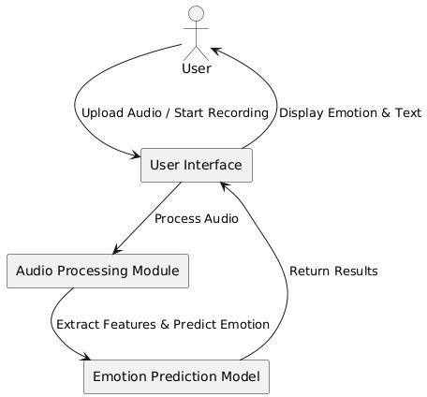
Figure 3.3.2 Data Flow Diagram

      - User: The User is the primary actor in the system, responsible for initiating the main actions. They interact with the User Interface by either uploading an audio file or starting a live recording, which triggers the system's data flow. After processing, the user receives the output, which includes the predicted emotion and the transcription of the spoken audio, if available. The user relies on the system to perform accurate analysis based on their audio input, whether it is a pre-recorded file or a live voice capture.
      - User Interface: The User Interface serves as the bridge between the User and the underlying system modules. It allows the user to upload audio files or start recording live input, then forwards this input to the Audio Processing Module for analysis. It also manages the display of results, showing the predicted emotion and transcribed text to the user in an easily interpretable format. The User Interface simplifies user interaction, abstracting complex processes into a user-friendly experience. It also handles any necessary error messages, such as alerts when audio cannot be processed, ensuring smooth and informative communication with the user.
      - Audio Processing Module: The Audio Processing Module is a crucial component that performs feature extraction on the audio data. Upon receiving audio input from the User Interface, it processes the audio by extracting essential features that can indicate emotional content. These features might

include Mel-frequency cepstral coefficients (MFCCs), pitch, intensity, and other spectral features that are important for emotion detection. The extracted features provide a structured representation of the audio data, making it suitable for machine learning models.
      - Emotion Prediction Model: The Emotion Prediction Model is responsible for analyzing the extracted audio features and predicting the user's emotion. This module utilizes trained machine learning algorithms, such as Random Forest, SVM, or Naive Bayes, to classify the emotional state conveyed by the audio input. It may also incorporate ensemble techniques to improve accuracy by combining predictions from multiple models. After generating the prediction, it sends the result (such as “happy,” “sad,” “angry,” etc.) back to the User Interface.
      - Result Display: Finally, the User Interface receives the predicted emotion and, if applicable, the transcribed text of the audio from the Emotion Prediction Model and Audio Processing Module, respectively. It then displays these results to the User in an organized and readable format. The result display ensures that users can quickly understand the emotional analysis and speech transcription, if available, allowing them to make decisions or take actions based on the output. By presenting both emotion and text output, the interface enables versatile use cases, such as real-time emotion monitoring, interactive voice-response systems, and sentiment analysis for customer support applications.

Class Diagram

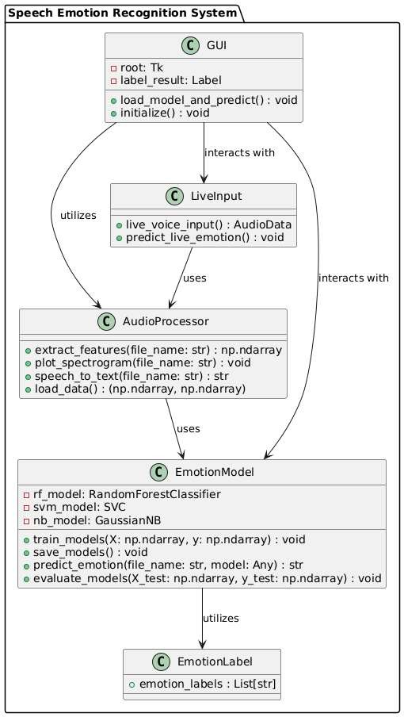

Figure 3.3.3 Class Diagram

      - GUI (Graphical User Interface): The GUI is the main interface that users interact with. It’s built using Tkinter and consists of a window and a label to display the results. It has methods for loading a machine learning model and making predictions, as well as for initializing the interface when the application starts. The GUI interacts with other components like live voice input, audio processing, and emotion prediction.
      - Live Input: The LiveInput class handles capturing real-time audio from the user's microphone. It has methods for recording audio and predicting the emotional state of the speaker based on the captured sound. It works with the AudioProcessor to extract features from the audio, which are then used by the EmotionModel to identify emotions.
      - Audio Processor: The AudioProcessor class is responsible for processing the audio and extracting important features. It has methods for extracting features like MFCCs, creating spectrograms, and converting speech to text. This class also loads training data for the machine learning models. It plays a critical role in transforming raw audio into data that the system can use for emotion prediction.
      - Emotion Model: The EmotionModel class is where the emotion prediction happens. It contains different machine learning models (Random Forest, SVM, Naive Bayes) that are trained to recognize emotions based on audio features. The models are trained using labeled data (audio features and corresponding emotions). The class has methods for training the models, saving them, making predictions, and evaluating their performance. This is the core part of the system that determines the emotional state of the speaker.
      - Emotion Label: The EmotionLabel class holds the names of the emotions that the system can predict (like "happy", "sad", "angry", etc.). These labels are used to convert the model's numerical predictions into human-readable emotions (e.g., 0 = "happy", 1 = "sad"). This class ensures that the system can display understandable results to the user.

Use case Diagram

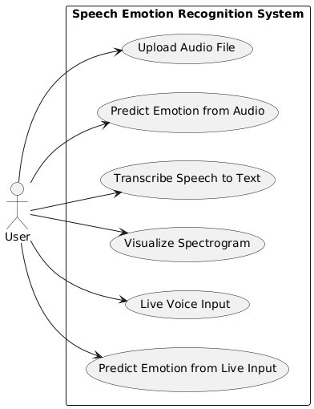
Figure 3.3.4 Use case Diagram
      - Actors: The primary actor in this system is the "User," who interacts with the Speech Emotion Recognition System (SERS). The user is responsible for triggering key actions in the system, such as uploading audio files, using live voice input, or viewing the emotional predictions and text transcriptions generated by the system. This actor represents any individual who uses the application to perform emotion recognition or transcription tasks.
      - Use Cases: The use case diagram defines six primary functionalities of the system that the user can interact with:
- Upload Audio File: This use case allows the user to upload an audio file into the system for further processing.
- Predict Emotion from Audio: Once the audio file is uploaded, this use case enables the system to analyze the file and predict the emotion conveyed in the speech, such as happy, sad, or angry.
- Transcribe Speech to Text: This use case transcribes the audio speech into text, making it easier for the user to read or analyze the spoken content.

- Visualize Spectrogram: The user can view a visual representation of the audio's frequency distribution over time through this use case, aiding in the analysis of the audio’s acoustic properties.
- Live Voice Input: This feature allows the user to provide real-time voice input using a microphone, enabling immediate analysis and predictions.
- Predict Emotion from Live Input: After capturing live voice input, the system can predict the user's emotional state based on the spoken words, making it suitable for interactive or real-time applications.
      - Relationships: In the diagram, the arrows from the "User" actor to each of the use cases indicate that the user initiates these actions. Each use case represents an operation or functionality that the user can access or trigger, with the user having control over all aspects of the interaction. The relationships suggest a direct connection between the user and the core tasks that define the system's operations, such as uploading files, predicting emotions, transcribing speech, or providing live input.
      - Diagram Structure: The use cases are grouped within the boundary of the "Speech Emotion Recognition System" rectangle, indicating that all these functionalities are part of the system’s scope. This grouping shows that these use cases are integral components of the overall system, encapsulating all the essential features the user can interact with. The diagram structure visually clarifies how the system operates from a user's perspective, defining the functionalities available within the scope of the Speech Emotion Recognition System.

Sequence Diagram

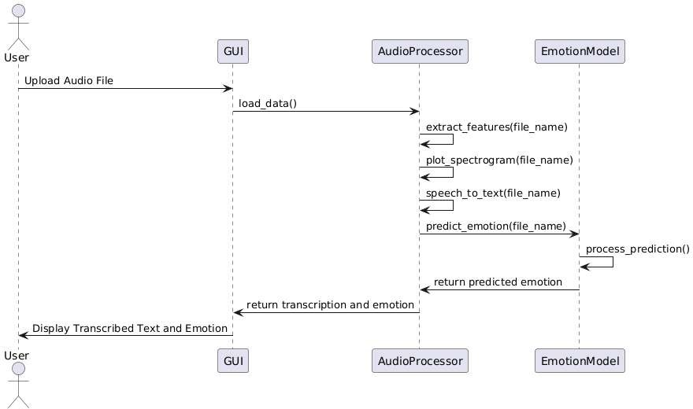
Figure 3.3.5 Sequence Diagram

      - User Initiates the Process: The sequence begins when the User uploads an audio file through the GUI. This is the first interaction the user has with the system, where they provide the input audio that will be processed for emotion recognition and speech-to-text conversion. This action triggers a series of operations that allow the system to process and analyze the audio.
      - GUI Handles the Upload: The GUI receives the uploaded file and communicates with the AudioProcessor to load the data from the file. This step prepares the system for feature extraction, spectrogram plotting, and transcription. Once the user uploads the file, the GUI handles the input by passing it to the AudioProcessor. The GUI serves as the interface through which the user interacts with the system, and it is responsible for coordinating the steps that follow the audio file upload. The AudioProcessor is called to load the data, preparing the system for feature extraction, spectrogram generation, and transcription.
      - AudioProcessor Processes the Audio: The first step involves extracting important features from the audio file. These features are used to predict the emotion conveyed in the speech. The system extracts Mel-frequency cepstral coefficients (MFCCs), chroma features, and mel-spectrograms to form a comprehensive feature vector representing the audio. The AudioProcessor also generates and plots the spectrogram of the audio, which provides a visual representation of the frequency distribution over time, helping in understanding the audio's acoustic characteristics. Simultaneously, the AudioProcessor transcribes the speech contained in the audio file into text. This transcription is a crucial step in converting spoken language into a readable format, enhancing the system’s usability.
      - Emotion Prediction: After processing the audio features and generating the spectrogram and transcription, the AudioProcessor sends the extracted features to the EmotionModel for emotion prediction. The EmotionModel uses these features to determine the emotional state of the speaker, such as whether the speaker is happy, sad, angry, or experiencing another emotion.
      - EmotionModel Processes the Prediction: The EmotionModel applies machine learning algorithms (like Random Forest, SVM, or Naive Bayes) to the features extracted from the audio. These models have been trained on labeled datasets, allowing them to classify emotions based on patterns in the acoustic features. The model processes the extracted features and determines the emotional label that best matches the speaker’s tone and speech characteristics.
      - Display Results in GUI: Finally, the AudioProcessor sends the transcribed text and the predicted emotion back to the GUI, which then displays these results to the User. The user can now view the transcription of the speech along with the emotion predicted by the system. This output is the final result that the user interacts with, providing both textual and emotional insights into the uploaded or spoken audio.

Activity Diagram

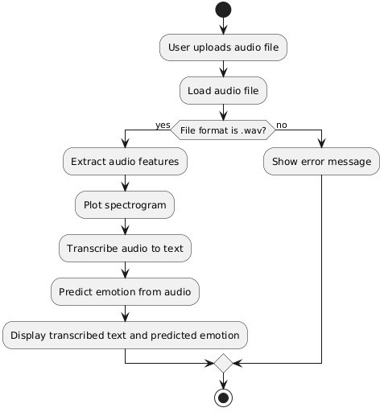
Figure 3.3.6 Activity Diagram
      - User Uploads Audio File : The process begins when a user uploads an audio file into the system. This file is expected to contain spoken content that will be analyzed for emotional cues. The interface for
this upload may provide instructions or restrictions on the type and size of audio files allowed. Allowing the user to upload the file is essential for starting the analysis process.
      - Load Audio File: After the file is uploaded, the system loads it for initial examination. Loading the file may involve reading metadata, checking audio quality, and preparing the data format for further analysis. This step is critical to ensure the audio file is compatible with the subsequent processing steps, such as feature extraction and transcription.
      - Check File Format: Here, the system checks if the file format is .wav. This is an important step because
.wav files are uncompressed and typically contain high-quality audio, which is preferable for analysis tasks that involve detailed feature extraction and transcription. If the file is in the .wav format, the

system proceeds; if not, it triggers an error message. This format validation helps to maintain consistency and reliability in the analysis process.
      - Extract Audio Features: Once the file format is validated, the system extracts audio features, which may include pitch, energy, formants, and Mel-Frequency Cepstral Coefficients (MFCCs), among others. These features represent various acoustic properties of the audio signal and are essential for identifying patterns that may indicate emotional expressions. Feature extraction is a critical step in making the raw audio data useful for machine learning algorithms.
      - Plot Spectrogram: A spectrogram is generated to visually represent the frequency spectrum of the audio signal over time. In this step, the system plots the spectrogram to visualize how energy is distributed across frequencies. This visual analysis is useful for both machine learning and human interpretation, as different emotions may have distinct spectrographic patterns, such as intensity in certain frequency bands.
      - Transcribe Audio to Text: After plotting the spectrogram, the system transcribes the spoken content in the audio into text. This transcription step is crucial because certain words and phrases can be emotionally charged, contributing to the overall emotion detection process. Natural language processing (NLP) models are often employed here to accurately convert audio to text, preserving as much context as possible for emotion analysis.
      - Predict Emotion from Audio: With both the audio features and transcription available, the system can predict the emotion in the audio file. Machine learning or deep learning models trained on emotion- labeled datasets are typically used here. The model analyzes vocal tone, intensity, pitch, and linguistic cues to predict emotions such as happiness, sadness, anger, or fear.
      - Display Transcribed Text and Predicted Emotion: Finally, the system displays the results to the user, showing both the transcribed text and the predicted emotion. This output provides the user with a comprehensive view of both the spoken content and the emotion inferred from it. By displaying both text and emotion, the system offers insights into not only what was said but also how it was likely expressed emotionally, which can be useful for applications in customer service, mental health, and sentiment analysis.
This end-to-end process ensures that users gain meaningful insights into both the verbal and emotional content of the audio file they uploaded.

CHAPTER-4 IMPLEMENTATION & TESTING

Coding Blocks

Import necessary libraries

import os
import numpy as np import librosa
import speech_recognition as sr
from sklearn.model_selection import train_test_split from sklearn.preprocessing import LabelEncoder
from sklearn.ensemble import RandomForestClassifier from sklearn.svm import SVC
from sklearn.naive_bayes import GaussianNB from sklearn.metrics import accuracy_score from tkinter import Tk, filedialog, Label, Button import joblib
import matplotlib.pyplot as plt import io

Feature Extraction

# Feature Extraction

def extract_features(file_name):

audio_data, sample_rate = librosa.load(file_name, res_type='kaiser_fast')

mfccs = np.mean(librosa.feature.mfcc(y=audio_data, sr=sample_rate, n_mfcc=40).T, axis=0) chroma = np.mean(librosa.feature.chroma_stft(y=audio_data, sr=sample_rate).T, axis=0) mel = np.mean(librosa.feature.melspectrogram(y=audio_data, sr=sample_rate).T, axis=0) return np.hstack([mfccs, chroma, mel])

Generate and plot spectrogram

# Generate and plot spectrogram

def plot_spectrogram(file_name):

audio_data, sample_rate = librosa.load(file_name, res_type='kaiser_fast') plt.figure(figsize=(10, 4))
D = librosa.amplitude_to_db(np.abs(librosa.stft(audio_data)), ref=np.max) plt.imshow(D, aspect='auto', cmap='inferno', origin='lower',
extent=[0, len(audio_data) / sample_rate, 0, sample_rate / 2]) plt.colorbar(format='%+2.0f dB')
plt.title('Spectrogram') plt.xlabel('Time (s)') plt.ylabel('Frequency (Hz)') plt.tight_layout() plt.show()

Speech-to-text conversion

# Speech-to-text conversion def speech_to_text(file_name):
recognizer = sr.Recognizer() audio_file = sr.AudioFile(file_name) with audio_file as source:
audio = recognizer.record(source) try:
text = recognizer.recognize_google(audio) return text
except sr.UnknownValueError: return "Speech not recognized"
except sr.RequestError:

return "Speech recognition service unavailable"

Load dataset and extract features

# Load dataset and extract features def load_data():
data = [] emotions = []
dataset_path = 'dataset/' # Ensure this path is correct for file in os.listdir(dataset_path):
if file.endswith('.wav'):

feature_vector = extract_features(os.path.join(dataset_path, file)) data.append(feature_vector)
emotion = int(file.split('-')[2]) # Adjust based on your filename format emotions.append(emotion)
return np.array(data), np.array(emotions)

# Emotion labels corresponding to the encoded labels

emotion_labels = ["happy", "sad", "angry", "fearful", "surprised", "neutral"]

Load and preprocess data

# Load and preprocess data X, y = load_data()
if len(X) == 0 or len(y) == 0:

raise ValueError("No data loaded. Please check your dataset directory.")

le = LabelEncoder()

y_encoded = le.fit_transform(y)

X_train, X_test, y_train, y_test = train_test_split(X, y_encoded, test_size=0.2, random_state=42)

Train models

# Train models

rf_model = RandomForestClassifier(n_estimators=100, random_state=42) rf_model.fit(X_train, y_train)

svm_model = SVC(kernel='linear') svm_model.fit(X_train, y_train)

nb_model = GaussianNB() nb_model.fit(X_train, y_train)

# Save models

joblib.dump(rf_model, 'random_forest.pkl') joblib.dump(svm_model, 'svm.pkl') joblib.dump(nb_model, 'naive_bayes.pkl')

Evaluation

# Evaluation

rf_pred = rf_model.predict(X_test) svm_pred = svm_model.predict(X_test) nb_pred = nb_model.predict(X_test)

print("Random Forest Accuracy:", accuracy_score(y_test, rf_pred)) print("SVM Accuracy:", accuracy_score(y_test, svm_pred)) print("Naive Bayes Accuracy:", accuracy_score(y_test, nb_pred))

Predict emotion

# Predict emotion

def predict_emotion(file_name, model):

features = extract_features(file_name).reshape(1, -1) prediction = model.predict(features)
return emotion_labels[prediction[0]] # Convert prediction index to label

Live voice input

# Live voice input

def live_voice_input(): recognizer = sr.Recognizer()
with sr.Microphone() as source: recognizer.adjust_for_ambient_noise(source) print("Please speak...")
audio = recognizer.listen(source) print("Audio captured, processing...")
return audio

Predict live emotion

def predict_live_emotion(): audio_data = live_voice_input()
audio_stream = io.BytesIO(audio_data.get_wav_data()) features = extract_features(audio_stream).reshape(1, -1)
model = joblib.load('random_forest.pkl') # You can switch models prediction = model.predict(features)
emotion = emotion_labels[prediction[0]]

# Convert speech to text

transcription = speech_to_text(io.BytesIO(audio_data.get_wav_data()))

# Update the GUI with results

label_result.config(text=f"Predicted Emotion: {emotion}\nTranscribed Text: {transcription}")

Tkinter GUI with speech-to-text

# Tkinter GUI with speech-to-text def load_model_and_predict():
file_path = filedialog.askopenfilename()

# Predict emotion

model = joblib.load('random_forest.pkl') # You can switch models emotion = predict_emotion(file_path, model)

# Get the speech-to-text result transcription = speech_to_text(file_path)

# Update the GUI with results

label_result.config(text=f"Predicted Emotion: {emotion}\nTranscribed Text: {transcription}")

# Plot spectrogram plot_spectrogram(file_path)

Tkinter GUI

# Tkinter GUI root = Tk()
root.title('Speech Emotion Recognition & Speech-to-Text')

label_result = Label(root, text="Upload an audio file or use live voice input", font=("Helvetica", 16)) label_result.pack()

btn_upload = Button(root, text="Upload Audio", command=load_model_and_predict) btn_upload.pack()

btn_live_voice = Button(root, text="Live Voice Input", command=predict_live_emotion) btn_live_voice.pack()

root.mainloop()

Execution Flow

Initialization:

      - The program begins by importing a variety of necessary libraries. These include audio processing libraries (librosa), machine learning libraries (scikit-learn), and user interface tools (Tkinter). The GUI components are set up next, where a Tk root window is created. This window contains a label that provides instructions to the user and two buttons: one for uploading an audio file and the other for capturing live voice input. The button clicks are linked to corresponding functions that handle each type of input, initiating the core functionalities of the program.

Model Training:

      - Upon initial startup, the program trains its emotion recognition models. This begins with the loading of a dataset containing audio files (in .wav format) from a predefined folder (dataset/). Each audio file is processed to extract key features using the extract_features() function, which computes Mel- frequency cepstral coefficients (MFCC), chroma features, and Mel spectrograms. These features are

then stored as input data for the model, while the corresponding emotion labels (such as "happy" or "sad") are assigned to each file.
      - The labels are encoded using LabelEncoder to convert them into numerical values that the machine learning models can understand. Next, the data is split into training and testing sets using train_test_split to evaluate the models’ performance. Three models—Random Forest Classifier, SVC, and Gaussian NB—are trained on the feature set and saved to disk using joblib. dump(). This step ensures that the models are ready to be used later in the program for emotion prediction.
      - Finally, the models are evaluated using the test data to determine their accuracy, with the accuracy scores printed for each model to provide feedback on their performance.

GUI Interaction: File Upload or Live Voice Input:

      - This section describes how the program interacts with the user via the GUI to either predict emotion from a pre-recorded audio file or from live voice input.
      - When the user clicks the "Upload Audio" button, the file dialog (filedialog.askopenfilename()) opens, allowing them to select an audio file from their local system. Once a file is chosen, the program proceeds to extract features from the selected audio using the extract_features() function. These features are then passed to the pre-trained models to predict the emotion. The model output (a numerical index) is mapped to the corresponding emotion label (e.g., "happy", "sad", etc.). In addition to emotion prediction, the program also performs speech-to-text conversion using Google's Speech Recognition API. The audio file is passed to the speech_to_text() function, which transcribes the spoken content into text. The program then updates the GUI with the predicted emotion and the transcribed text.
      - When the user clicks the "Live Voice Input" button, the program activates the microphone to capture real-time audio using the live_voice_input() function. This function listens for speech and records it in real time. After the audio is captured, it is processed just like an uploaded file: features are extracted using extract_features(), and the saved machine learning models are used to predict the emotion in the voice.

Results Display and GUI Main Loop:

      - Once either a file is uploaded or live voice input is captured and processed, the program updates the GUI with the relevant results. The predicted emotion (e.g., "happy", "sad") and the transcribed text are shown in the label of the GUI. The spectrogram for uploaded files is also visualized in a separate window. The Tkinter event loop (root.mainloop()) ensures that the window remains responsive and interactive, continuously listening for user input until the program is closed.

CHAPTER-5 RESULTS

5.1 Resulting Screen

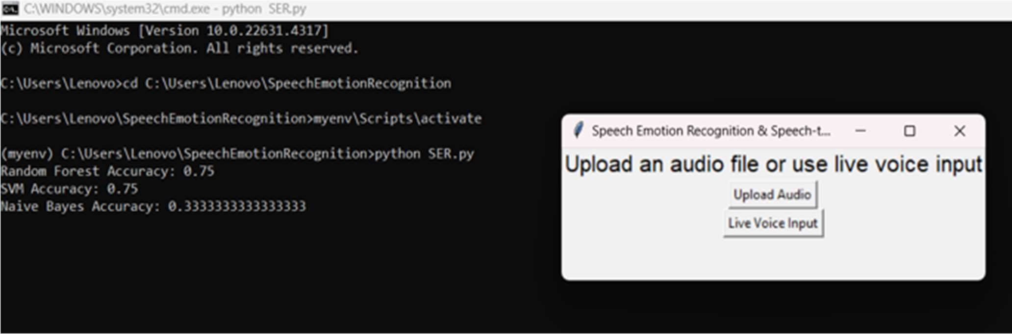

Screenshot 5.1 User Interface

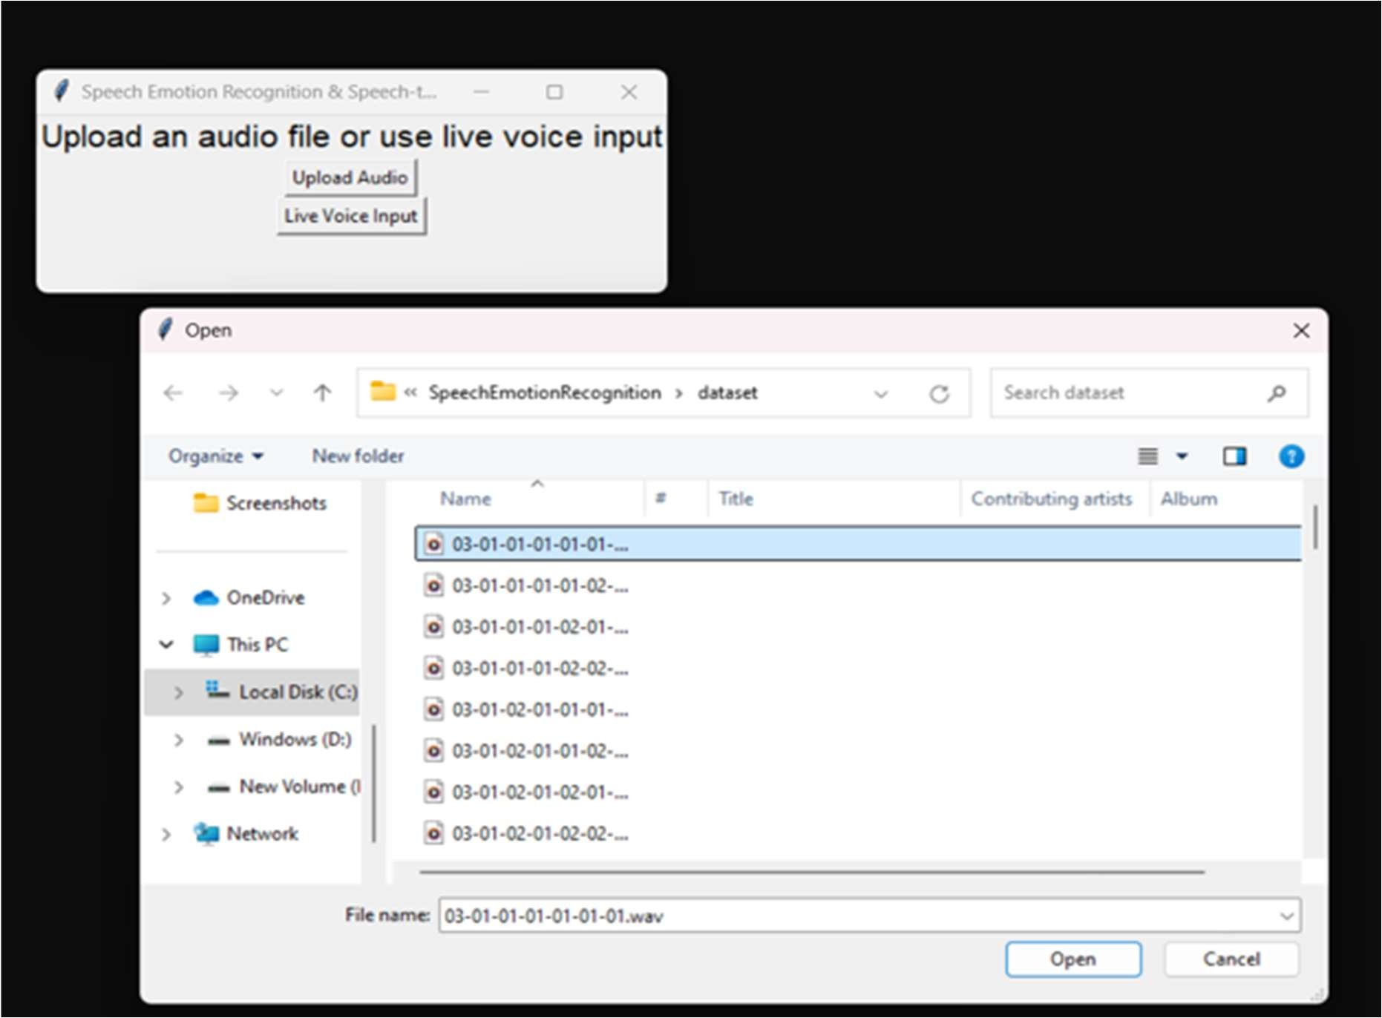

Screenshot 5.2 Uploading audio files

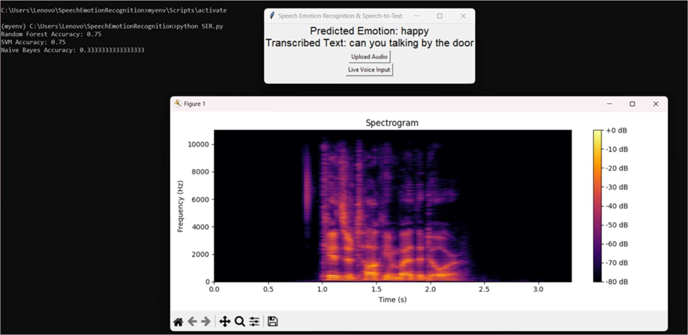

Screenshot 5.3 Spectrogram for audio file
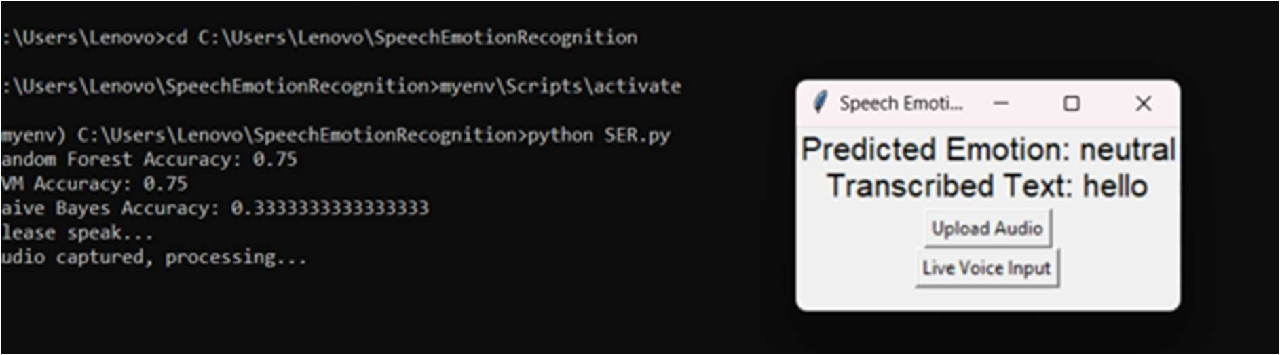

Screenshot 5.4 Live voice input and result

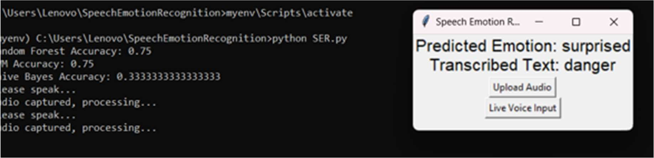

Screenshot 5.5 Live voice input and result

CHAPTER-6 CONCLUSIONS & FUTURE SCOPE

Conclusions

In conclusion, the Speech Emotion Recognition (SER) project represents a significant advancement in the intersection of machine learning and emotional intelligence, providing a robust framework for accurately identifying and classifying human emotions from vocal inputs. By leveraging advanced acoustic analysis and machine learning algorithms such as Support Vector Machines, Random Forests, and Naive Bayes, the system demonstrates its versatility in handling diverse emotional datasets across different languages and accents. The integration of graphical representations and speech-to-text capabilities further enhances its utility, making it a valuable tool for various applications, including mental health assessment, customer service, and human-computer interaction. The inclusion of graphical data visualizations and speech-to-text functionalities adds another layer of depth to the project, enabling users to engage with emotional data in a more interactive and informative manner. As the project evolves, future enhancements like multimodal emotion recognition, real-time monitoring, and personalized user experiences will pave the way for more intuitive and empathetic technological interactions. Overall, the SER project not only addresses current challenges in emotion detection but also lays the foundation for innovative solutions that can improve emotional awareness and communication in numerous fields. By addressing current limitations and exploring new applications, the project not only meets a pressing need in emotional intelligence but also sets the stage for future innovations in human-computer interaction.

Future Scope

The future scope of the Speech Emotion Recognition (SER) project is promising and multifaceted, with potential advancements that could significantly enhance its functionality and application. One primary area of development lies in the improvement of the underlying machine learning models. By incorporating more sophisticated algorithms, such as deep learning techniques like Long Short-Term Memory (LSTM) networks and convolutional neural networks (CNNs), the system could achieve higher accuracy in emotion classification. Additionally, fine-tuning the existing models through techniques like transfer learning could enable better performance with limited datasets, thus broadening the project's applicability. Another crucial aspect of the future scope is the expansion of the dataset used for training and testing the models. By including a more diverse range of emotional expressions, languages, and accents, the system can be made more robust and inclusive. Collaborating with linguistic experts to collect annotated emotional data can enhance the model’s ability to understand subtle emotional cues, resulting in more reliable predictions across

different demographic groups. Real-time emotion recognition capabilities can be advanced to support integration with various applications, such as virtual assistants, customer service platforms, and mental health monitoring tools. This integration could enable these systems to respond more empathetically to users, improving human-computer interactions. Future iterations of the project could explore the incorporation of multimodal approaches, combining audio analysis with visual cues from facial expressions or body language. This holistic approach would provide a more comprehensive understanding of human emotions, leading to even more effective applications in fields like mental health, education, and customer relationship management.

BIBLIOGRAPHY
- Mirsamadi, S., Barsoum, E., & Zhang, C. (2017). Automatic Speech Emotion Recognition Using Recurrent Neural Networks with Local Attention. ICASSP 2017 – IEEE International Conference on Acoustics, Speech and Signal Processing.

- Arpita Mishra, Busso, C., Lee, S., & Narayanan, S. S. (2009). Analysis of Emotion Recognition Using Facial Expressions, Speech, and Multimodal Information.

- Ververidis, & Kotropoulos, C. (2006). Emotional Speech Recognition: Resources, Features, and Methods. Speech Communication.

- Pandharipande, R., & Soni, S. (2019). Speech Emotion Recognition Using SVM and Random Forest Algorithms. International Journal of Engineering and Advanced Technology.

- K. Shaukat, & Chen, Y. (2020). Enhancing Emotion Recognition from Speech Using Feature Selection and Ensemble Learning Techniques.

- Shami, M., & Verhelst, W. (2007). An Evaluation of the Robustness of Existing Supervised Machine Learning Approaches to the Classification of Emotions in Speech.

- Yoon, S., Ko, H., & Lee, K. (2018). Multi-level Attention Model for Speech Emotion Recognition. Interspeech 2018 – 19th Annual Conference of the International Speech Communication Association.

- S. K. Saha, A. Ghosh, and S. R. Mandal, "Speech Emotion Recognition using Machine Learning Techniques," International Journal of Advanced Research in Computer Science and Software Engineering.

Paper Publication
Speech Emotion Recognition

Mrs. K. Rashmi CSE (CS AND IOT)
Malla Reddy University, rashmi.naidu5@gmail.com

L. Murari
Computer Science & Engineering IoT
Malla Reddy University 2211cs050058@mallareddyuniversity.ac.in

Abstract- This research explores the development of a machine learning-based Speech Emotion Recognition (SER) system designed to accurately detect and categorize human emotions from vocal inputs. The system employs advanced acoustic analysis, focusing on features like pitch, intensity, and speech rate, to capture emotional subtleties in speech. Leveraging algorithms such as Support Vector Machines (SVM), Random Forest, and Naive Bayes, the model is trained on a wide array of emotional datasets, enabling effective performance across diverse languages and accents. To improve the accuracy of emotion detection, feature selection methods and ensemble learning are incorporated, enhancing the model’s precision. Beyond emotion classification, the system generates graphical representations of emotional patterns and provides text transcriptions of the audio input, adding depth to the analysis. Potential applications span multiple domains: from improving human-computer interaction in virtual assistants and customer service systems by recognizing emotional cues to assisting mental health professionals with tools for emotional assessment. The long-term objective envisions real-time emotion recognition, fostering more adaptive and intuitive user experiences across various interactive platforms. Integrating speech-to-text capabilities further enriches the system, transforming vocal expressions into textual and emotional insights.
Keywords-Speech Emotion Recognition, Speech-to-Text, random forests, Support Vector Machine (SVM), Emotion Detection
INTRODUCTION
Understanding emotions through speech has become an essential component of creating intuitive, responsive systems in human-computer interaction. Emotions conveyed in vocal expressions carry important contextual information that, if accurately detected and interpreted, can significantly enhance user experiences across various applications. Speech Emotion Recognition (SER) aims to classify these emotions by analyzing vocal characteristics such as pitch, intensity, and speech rate, which are critical indicators of emotional states. Traditional text-based sentiment analysis lacks the capacity to capture this vocal dimension, which is where SER can fill an essential gap. This research investigates the development of a machine learning-based SER system that not only identifies but also categorizes emotions from speech, leveraging advanced acoustic feature analysis. The project integrates a range of machine learning algorithms to improve the precision and reliability of emotion classification. By analyzing audio signals and identifying emotion patterns, SER enables applications such as real-time customer service enhancements, educational tools that adapt to student emotions, and healthcare support systems that detect stress or emotional distress in patients. To further refine the model’s performance, the system employs feature selection and ensemble learning techniques, ensuring adaptability to diverse vocal inputs and consistency across languages and accents. Additionally, this SER system is designed to produce graphical representations of emotional trends and transcribe speech content, offering a dual-layered approach to understanding both the verbal and emotional aspects of communication. Such a system has far-reaching applications, from enhancing virtual assistants with emotion-aware responses to providing tools for mental health professionals who require insights into emotional dynamics. Ultimately, this research contributes to the ongoing evolution of human-computer interaction, highlighting the importance of emotional intelligence in creating more empathetic and responsive systems.

  - BACKGROUND & RELATED WORK
El Ayadi, M., Kamel, M. S., & Karray, F. "Speech Emotion Recognition: Features, Classification Schemes, and Databases"
El Ayadi et al. (2011) provided an extensive survey of SER techniques, focusing on both classical and advanced classification models like Gaussian Mixture Models (GMM), SVM, and Neural Networks. They analyzed various emotional datasets, highlighting the need for diverse, multilingual datasets to improve the generalizability of SER systems. Their work emphasized the importance of feature selection in improving model accuracy, contributing insights that are instrumental for systems designed to handle varied linguistic and acoustic inputs.

K.Han, & Tashev.I "Speech Emotion Recognition Using Deep Neural Network and Extreme Learning Machine", explored the use of deep neural networks (DNN) and extreme learning machines (ELM) for SER. Their study highlighted the effectiveness of DNNs in automatically learning hierarchical features from raw audio, improving emotion recognition performance over traditional feature extraction. While deep learning models achieved high accuracy, the authors noted that these models were computationally expensive, suggesting that hybrid approaches combining deep learning and traditional algorithms might optimize efficiency. Despite the high performance of DNNs in recognizing emotions, the researchers pointed out the significant computational demands associated with training and deploying these deep models, which can pose challenges in real-time or resource- constrained environments. heir work underscored the potential of using deep learning in SER while advocating for innovative, efficient solutions that address computational limitations.

Busso.C, M. Bulut, C. Lee, A. Kazemzadeh, E. Mower,
S. Kim, J. Chang, & S. Narayanan, "IEMOCAP: Interactive Emotional Dyadic Motion Capture Database" The IEMOCAP (Interactive Emotional Dyadic Motion Capture) dataset, introduced by Busso et al. in 2008, has significantly advanced the field of Speech Emotion Recognition (SER) by providing a robust, multimodal dataset specifically tailored for emotion research. This dataset includes extensive recordings of actors performing both scripted and improvised dialogues, capturing a wide range of emotional expressions through audio, video, and motion-capture data. The multimodal nature of IEMOCAP enables researchers to leverage audio cues like pitch, intensity, and tone in tandem with visual gestures and facial expressions, which are critical in identifying nuanced emotions. The dataset contains five sessions with multiple speakers, and each session is manually annotated with emotion labels such as anger, happiness, sadness, and neutral. This rich labeling and data diversity help develop
more generalizable and accurate emotion classification models, especially in real-world applications where emotions are often expressed through subtle and combined cues. Consequently, IEMOCAP has become one of the most frequently used datasets in SER, supporting a variety of machine learning and deep learning research projects that aim to enhance human-computer interaction by accurately interpreting emotional cues in speech.

S. K. Saha, A. Ghosh, and S. R. Mandal, " Speech Emotion Recognition using Machine Learning Techniques".
The research paper offers a comprehensive comparative analysis of various machine learning techniques utilized for Speech Emotion Recognition (SER), focusing on algorithms such as Support Vector Machines (SVM), Random Forest, Decision Trees, and K-Nearest Neighbors (KNN). The authors designed a series of experiments employing a diverse range of audio datasets, which allowed for a thorough evaluation of each algorithm’s performance across different emotional classifications The authors discuss how considerations such as computational efficiency, accuracy, and scalability play a crucial role in determining the most suitable algorithms for SER applications, particularly in real-world settings where resources may be limited.
  - EXISTING SYSTEM
This existing system adopts a specialized approach to recognizing emotions in speech by using traditional feature extraction techniques, steering clear of spectrogram analysis and live voice input. By focusing exclusively on pre-recorded speech samples, the system targets a specific range of emotions, namely joy, anger, sadness, and surprise. This concentration allows for a more straightforward process in identifying emotional states through fundamental temporal and spectral features extracted from the audio signals. The feature extraction process is crucial for the system's efficacy. It quantifies various acoustic parameters that are closely linked to emotional expression, such as the fundamental frequency (F0), which pertains to voice pitch, energy levels that reflect vocal intensity, and speech rate that indicates the speed of speech. Through the application of statistical techniques to these features, the system can identify unique patterns corresponding to each of the specified emotions, thereby improving the accuracy of emotion classification. For classification, the system utilizes a Gaussian Mixture Model (GMM), which adeptly represents the underlying probability distribution of the feature space associated with each emotion category. This probabilistic method enables the system to accommodate the natural variability present in speech data, facilitating the differentiation of emotional

states based on the statistical characteristics of the extracted features. One significant advantage of this system is its computational efficiency, making it ideal for implementation on devices with limited processing power, such as smartphones or embedded systems. This efficiency arises from the use of traditional acoustic features instead of more sophisticated methods that demand higher computational resources. However, by not employing advanced techniques like spectrogram analysis, the system may find it challenging to detect subtle emotional cues often revealed in more complex acoustic patterns, which could result in overlooked emotional subtleties.
Lack of Real-Time Processing: The existing system analyzes pre-recorded audio samples rather than processing live voice inputs. This restricts its applicability in dynamic environments where real-time emotion recognition is essential, such as in virtual assistants or customer service scenarios. The proposed system, however, is designed to operate in real-time, allowing for immediate feedback and interaction.
Limited Feature Set: The existing system relies on basic temporal and spectral features, such as fundamental frequency, energy levels, and speech rate. This limited feature set may fail to capture the rich acoustic characteristics of speech that convey emotional nuances.
  - Proposed system
The proposed Speech Emotion Recognition (SER) system aims to develop an advanced machine learning framework capable of accurately identifying and classifying human emotions from vocal inputs. Utilizing a combination of feature extraction techniques and various machine learning algorithms, the system processes audio samples to interpret emotional content effectively. Key acoustic features such as Mel-frequency cepstral coefficients (MFCCs), chroma features, and mel spectrograms are extracted from audio recordings, providing a rich representation of the underlying emotional states. The system employs multiple classifiers, including Random Forest, Support Vector Machines (SVM), and Naive Bayes, to enhance accuracy and reliability in emotion detection. To facilitate real-time emotion recognition, the system incorporates a graphical user interface (GUI) built with Tkinter, allowing users to upload audio files for analysis seamlessly. Additionally, it integrates speech-to-text capabilities, converting spoken words into text and providing transcription alongside emotional classification results. The proposed system's comprehensive approach not only enhances human- computer interaction, particularly in applications such as virtual assistants and customer service platforms, but also serves as a valuable tool for mental health professionals by delivering insights into emotional states. Ultimately, the project aims to contribute to a more intuitive and empathetic user experience by enabling real-time emotional feedback and adaptation in various contexts. In conclusion, the proposed Speech Emotion Recognition
(SER) system represents a significant advancement in the field of emotion detection, leveraging sophisticated machine learning techniques and comprehensive feature extraction methods to analyze vocal inputs effectively. The inclusion of a user-friendly graphical interface and speech-to-text functionality further enhances its practical applications, making it suitable for diverse fields such as virtual assistance, customer service, and mental health support.
A. Python and libraries
In the realm of speech emotion recognition, Python has emerged as an invaluable tool, facilitating the development of sophisticated models for analyzing and classifying human emotions from vocal inputs. Its extensive ecosystem of libraries provides the necessary resources for efficient audio processing, feature extraction, and machine learning, making it an ideal choice for projects in this field. Librosa, a powerful library tailored for audio analysis, plays a pivotal role in this project by enabling the extraction of essential acoustic features such as Mel-frequency cepstral coefficients (MFCCs) and chroma features.

The project also leverages the capabilities of Pandas for data manipulation, facilitating the organization and preprocessing of the datasets used for training and evaluating the emotion recognition models. To visualize the emotional trends and patterns in the data, the project utilizes Matplotlib, which provides essential plotting capabilities. This enables the creation of informative graphics that support data exploration and help interpret the outcomes of the emotion recognition models. Overall, Python’s robust libraries and frameworks significantly contribute to the effectiveness and efficiency of the speech emotion recognition system, driving innovation in human-computer interaction and emotion-aware technologies.
  - METHODOLOGY

The methodology for the Speech Emotion Recognition (SER) project involves several key steps designed to ensure effective data processing, feature extraction, model training, and evaluation. Initially, the project begins with the collection of a diverse dataset comprising audio samples representing various emotions, ensuring a comprehensive representation of human emotional expression. The audio data undergoes preprocessing, which includes noise reduction and normalization to enhance the quality of the recordings. Once the data is prepared, feature extraction is performed using techniques such as Mel-frequency cepstral coefficients (MFCCs), chroma features, and mel- spectrograms. These features capture essential acoustic characteristics relevant to emotion detection and are crucial for the subsequent machine learning processes. The extracted features are then organized into a structured format suitable for analysis. Next, the project employs multiple machine learning algorithms, including Support Vector Machines (SVM), Random Forests, and Naive Bayes, to

train classification models. After training, the models are assessed using a variety of evaluation metrics, including confusion matrices and classification reports, to determine their effectiveness in emotion recognition. Finally, the project integrates a user-friendly interface that enables real- time emotion detection from live voice input, along with visualization tools to present the emotional trends and transcriptions of the audio. The methodology employed in this Speech Emotion Recognition (SER) project presents a structured approach for effective emotion detection from vocal inputs. By carefully gathering and preprocessing data, extracting meaningful features, and training multiple machine learning models, this methodology addresses the complexities of accurately identifying emotions across diverse audio samples. Each step, from feature extraction to model evaluation, contributes to a robust system capable of real-time emotion recognition and transcription. The integration of a user-friendly interface further enhances accessibility, allowing seamless interaction with the model.

Architecture Diagram



The architecture diagram of the Speech Emotion Recognition System presents a high-level overview of the various components and their interactions. At the core of the system is the User Interface, which serves as the primary point of interaction for users, enabling them to upload audio files, initiate voice recognition, and receive feedback on emotional predictions. The Audio File Handler is responsible for managing audio data, including loading files and extracting relevant features that are crucial for emotion analysis. Complementing the prediction functionality is the Speech Recognition Module, which converts spoken language into text, allowing for accurate transcription of user input. This module enhances user experience by facilitating real-time voice interaction.
- 2ALGORITHMS USED
Random Forests as an ensemble learning method, contributes to improved accuracy and robustness by aggregating multiple decision trees, making it well-suited for capturing diverse patterns in emotional expressions.
SVM(Support Vector Machine ) is applied for its strong classification capabilities, effectively separating emotional states based on high-dimensional features extracted from audio signals.

Naive Bayes known for its probabilistic approach, complements the classification process by offering efficient and reliable predictions even with limited training data.

Together, these algorithms enhance the system’s ability to interpret nuanced vocal characteristics, such as pitch, tone, and rhythm, thus providing a comprehensive and precise emotion recognition framework.
- OBJECTIVES
The primary objective of the Speech Emotion Recognition (SER) project is to develop a sophisticated system that accurately identifies and classifies human emotions from vocal inputs. A key focus is on comprehensive feature extraction, utilizing acoustic features like Mel-frequency cepstral coefficients (MFCCs) and chroma features to capture the emotional nuances in speech.
The system's particular objectives are as follows:
  - To create a robust machine learning model capable of accurately identifying and classifying a range of human emotions from vocal inputs, leveraging advanced acoustic features.
  - To extract key acoustic features such as Mel- frequency cepstral coefficients (MFCCs), chroma features, and mel spectrograms from audio samples, ensuring a rich representation of emotional content.
  - To incorporate speech recognition capabilities that convert spoken language into text, providing additional context and insights alongside emotion classification results.
  - To develop a graphical user interface (GUI) that facilitates easy interaction with the system, allowing users to upload audio files, view emotional trends, and access transcriptions in a seamless manner.
- IMPLEMENTATION
The implementation of the Speech Emotion Recognition (SER) project involves several key stages, beginning with the collection and preprocessing of audio data. Initially, a diverse dataset containing various emotional expressions is gathered, ensuring it encompasses multiple languages and accents. The audio samples are then processed using the Librosa library, which facilitates the extraction of critical acoustic features, including Mel-frequency cepstral coefficients (MFCCs), chroma features, and mel spectrograms. These features serve as the foundation for training the machine learning models. Subsequently, various algorithms, such as Random Forests, Support Vector Machines (SVM), and Naive Bayes, are employed to build the emotion classification models. The project also integrates functionality for live voice input,

enabling real-time emotion recognition. This is achieved through microphone access, allowing the system to capture and analyze vocal inputs on the fly. The Speech Recognition library is utilized to convert spoken input into text while concurrently analyzing its emotional content. A user- friendly graphical user interface (GUI) is developed using Tkinter, providing an intuitive platform for users to upload Audio files, view emotion predictions, and access transcriptions.
- RESULTS
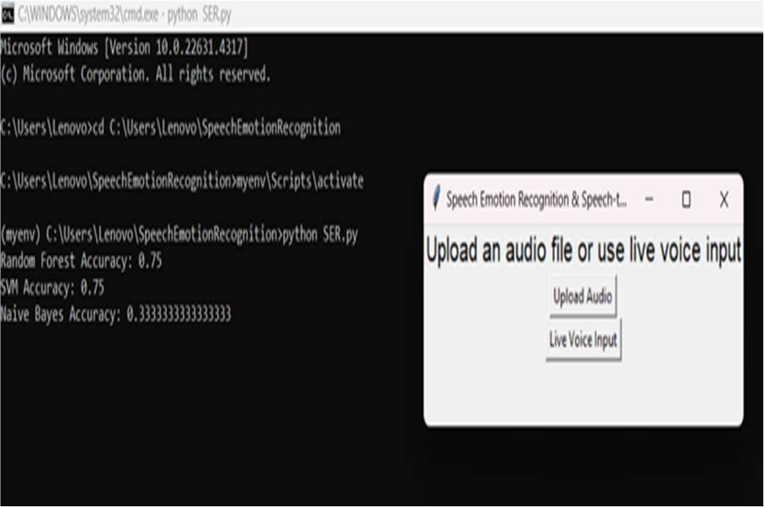
fig(1): User Interface

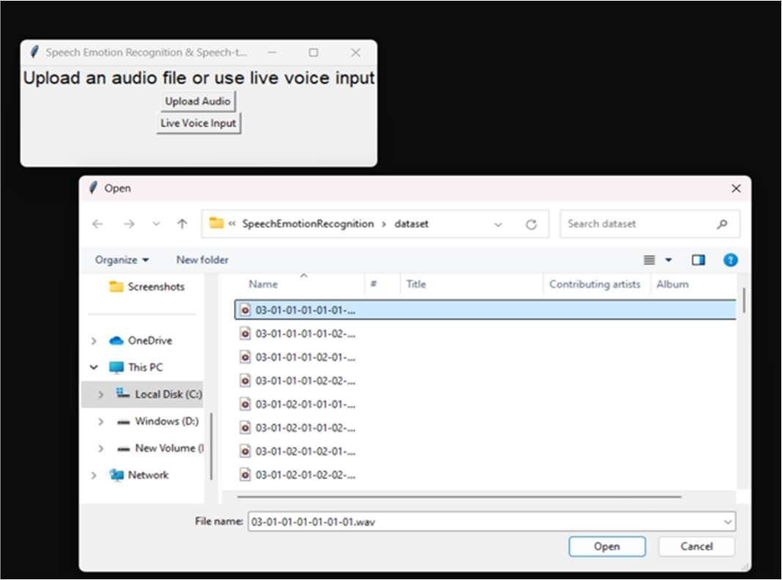
fig(2): Uploading audio files
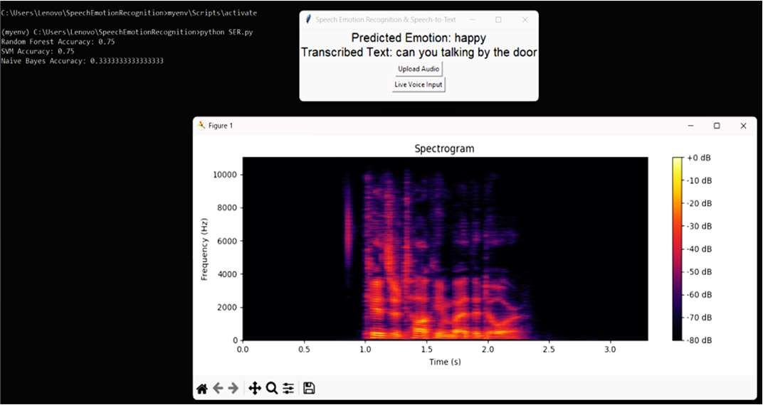
fig(3): Spectrogram for audio file

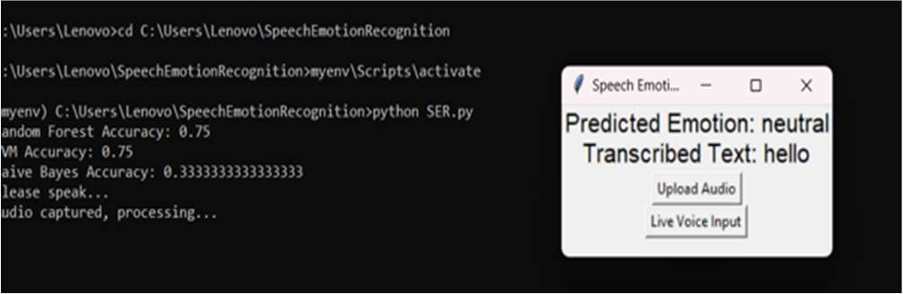
fig(4): Live voice input and result
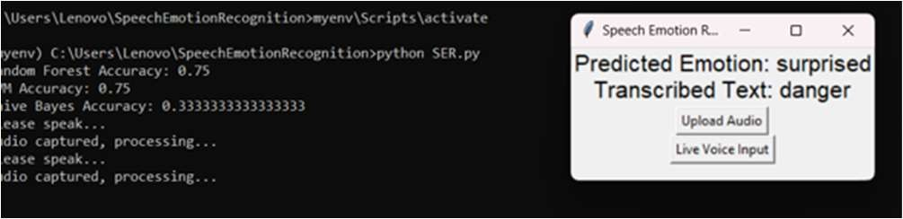
fig(5): Live voice input and result

- FUTURE SCOPE
The future scope of the Speech Emotion Recognition (SER) project is promising and multifaceted, with potential advancements that could significantly enhance its functionality and application. One primary area of development lies in the improvement of the underlying machine learning models. By incorporating more sophisticated algorithms, such as deep learning techniques like Long Short-Term Memory (LSTM) networks and convolutional neural networks (CNNs), the system could achieve higher accuracy in emotion classification. Additionally, fine-tuning the existing models through techniques like transfer learning could enable better performance with limited datasets, thus broadening the project's applicability. Another crucial aspect of the future scope is the expansion of the dataset used for training and testing the models. By including a more diverse range of emotional expressions, languages, and accents, the system can be made more robust and inclusive. Collaborating with linguistic experts to collect annotated emotional data can enhance the model’s ability to understand subtle emotional cues, resulting in more reliable predictions across different demographic groups. Real-time emotion recognition capabilities can be advanced to support integration with various applications, such as virtual assistants, customer service platforms, and mental health monitoring tools. This integration could enable these systems to respond more empathetically to users, improving human-computer interactions. Future iterations of the project could explore the incorporation of multimodal approaches, combining audio analysis with visual cues from facial expressions or body language. This holistic approach would provide a more comprehensive understanding of human emotions, leading to even more effective applications in fields like mental health, education, and customer relationship management. One promising extension of the SER project is the development of a sentiment analysis tool for social media platforms, where the system could analyze user- generated voice content to gauge public sentiment regarding specific topics or events. This feature could provide valuable insights for businesses and policymakers, allowing them to understand consumer emotions and adjust their strategies accordingly.

- CONCLUSION
In conclusion, the Speech Emotion Recognition (SER) project represents a significant advancement in the intersection of machine learning and emotional intelligence, providing a robust framework for accurately identifying and classifying human emotions from vocal inputs. By leveraging advanced acoustic analysis and machine learning algorithms such as Support Vector Machines, Random Forests, and Naive Bayes, the system demonstrates its versatility in handling diverse emotional datasets across different languages and accents. The integration of graphical representations and speech-to-text capabilities further enhances its utility, making it a valuable tool for various applications, including mental health assessment, customer service, and human-computer interaction. The inclusion of graphical data visualizations and speech-to-text functionalities adds another layer of depth to the project, enabling users to engage with emotional data in a more interactive and informative manner. As the project evolves, future enhancements like multimodal emotion recognition, real-time monitoring, and personalized user experiences will pave the way for more intuitive and empathetic technological interactions. Overall, the SER project not only addresses current challenges in emotion detection but also lays the foundation for innovative solutions that can improve emotional awareness and communication in numerous fields. By addressing current limitations and exploring new applications, the project not only meets a pressing need in emotional intelligence but also sets the stage for future innovations in human-computer interaction.

- REFERENCES

- El Ayadi, M., Kamel, M. S., & Karray, F. "Speech Emotion Recognition: Features, Classification Schemes, and Databases"

- Busso, C., Lee, S., & Narayanan, S. S. (2009). Analysis of Emotion Recognition Using Facial Expressions, Speech, and Multimodal Information.

- K.Han, & Tashev.I "Speech Emotion Recognition Using Deep Neural Network and Extreme Learning Machine".

- S. K. Saha, A. Ghosh, and S. R. Mandal, "Speech Emotion Recognition using Machine Learning Techniques," International Journal of Advanced Research in Computer Science and Software Engineering.

- Pandharipande, R., & Soni, S. (2019). Speech Emotion Recognition Using SVM and Random Forest Algorithms. International Journal of Engineering and Advanced Technology.

- Shaukat, Z., & Chen, Y. (2020). Enhancing Emotion Recognition from Speech Using Feature Selection and Ensemble Learning Techniques.

- Lotfian, R., & Busso, C. (2019). Building Naturalistic Emotionally Balanced Speech Corpus by Retrieving Emotional Speech from Existing Podcast Recordings.

- Shami, M., & Verhelst, W. (2007). An Evaluation of the Robustness of Existing Supervised Machine Learning Approaches to the Classification of Emotions in Speech.

- Yoon, S., Ko, H., & Lee, K. (2018). Multi-level Attention Model for Speech Emotion Recognition. Interspeech 2018 – 19th Annual Conference of the International Speech Communication Association.

- Poria, S., Cambria, E., Howard, N., Huang, G.-B., & Hussain, A. (2016). "Fusing audio, visual and textual clues for sentiment analysis in video." Proceedings of the IEEE International Conference on Neural Networks, 1633-1637.

- Ververidis, D., & Kotropoulos, C. (2006). "Emotional speech recognition: Resources, features, and methods." Speech Communication.

- B. Schuller, G. Rigoll, and M. Lang (2003). "Speech Emotion Recognition Combining Acoustic Features and Linguistic Information.

- Koolagudi, S. G., & Rao, K. S. (2012). "Emotion recognition from speech: A review." International Journal of Speech Technology, 15(2), 99-117.

- Morrison, G. S., & Neumann, C. (2020). "The Role of Forensic Science in the Interpretation of Digital Evidence." Forensic Science International, 309, 110193.

- Eyben, F., Wöllmer . (2010). "OpenSMILE - The Munich versatile and fast open-source audio feature extractor." Proceedings of the ACM Multimedia.

Poster

